1.Simulate a small network with switches and multiple devices. Use ping to generate traffic and observe the MAC address table of the switch. Capture packets using Wireshark to analyze Ethernet frames and MAC addressing.

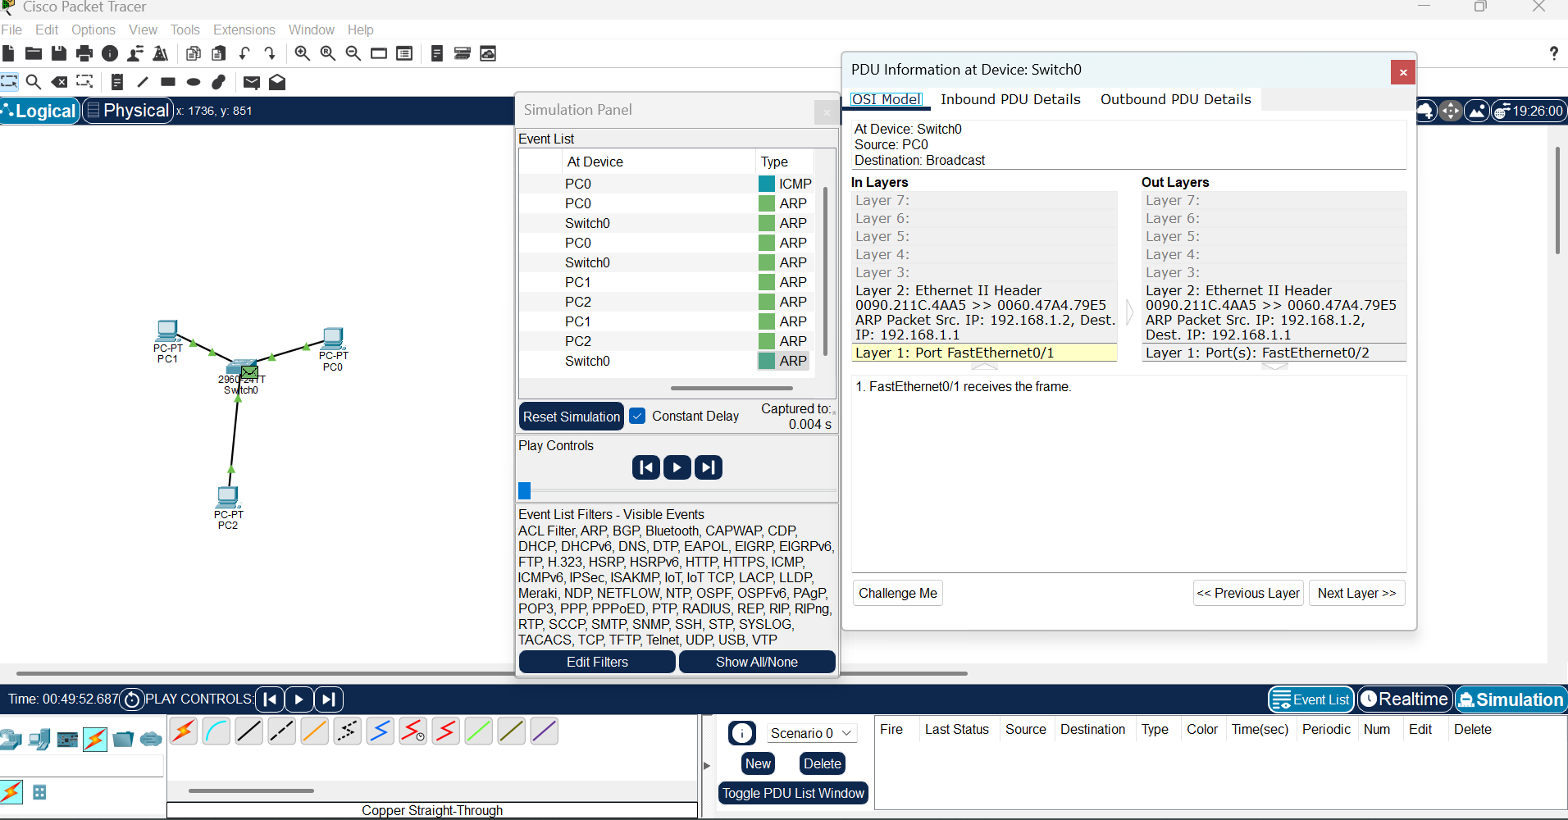

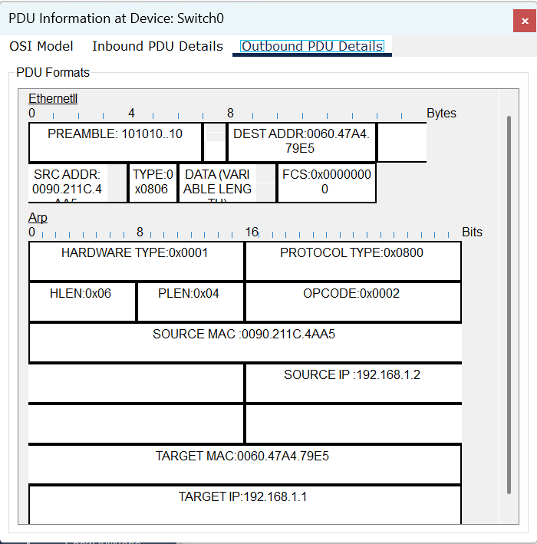

2. Capture and analyze Ethernet frames using Wireshark. Inspect the structure of the frame, including destination and source MAC addresses. Ethertype, payload and FCS. Use GNS3 or Packet Tracer to simulate network traffic.

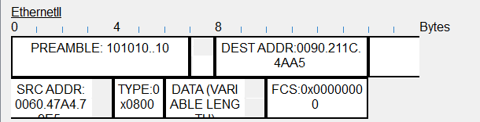

3. Configure static IP addresses, modify MAC addresses, and verify network connectivity using ping and ifconfig commands.

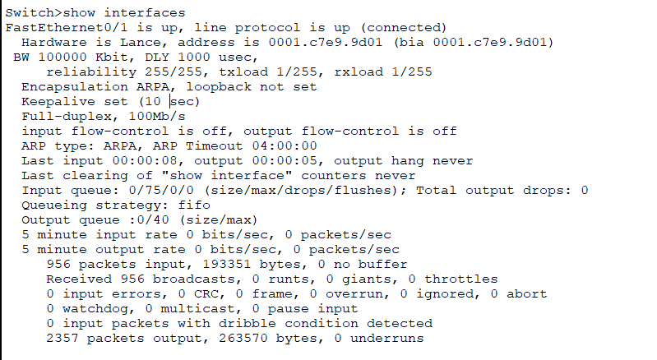

4. Troubleshoot Ethernet Communication with ping and tracerout using cisco packet tracer

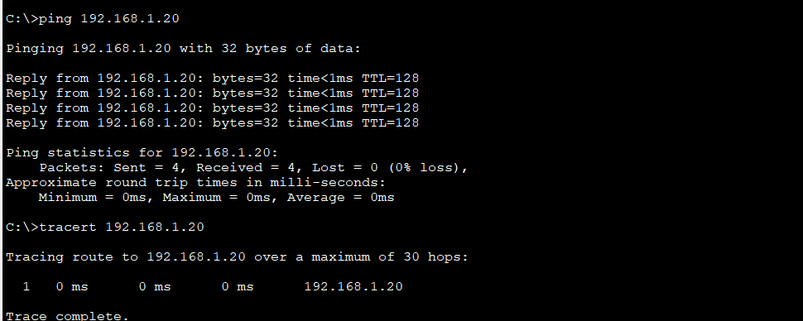

Report and Observation

1. Linux Kernel's Handling of Ethernet Communication

Network Interface Drivers: Ethernet interfaces (e.g., eth0, enp0s3) are managed by device drivers specific to network hardware.

Packet Processing: Incoming and outgoing packets pass through the kernel’s networking stack, which consists of layers such as the Link Layer, IP Layer, and Transport Layer.

ARP (Address Resolution Protocol): The kernel maintains an ARP cache to resolve IP addresses to MAC addresses.

Netfilter and iptables: Packet filtering, NAT, and firewalling are handled via Netfilter hooks in the kernel.

sysfs and procfs: The kernel exposes network configuration and statistics via /sys/class/net/ and /proc/net/.

2. Configuring a Basic LAN interface Using ip Command

1. sudo ip addr add 192.168.1.10/24 dev enp0s3
2. sudo ip link set enp0s3 up
3. ip addr show enp0s3

ip route show

